**SPATIAL MECHANISMS AND DYNAMICAL SYSTEMS**

**1/ Theory**

Please describe the Lagrangian methods for linear dynamical systems, the Lagrangian equations. Please compare the Lagrangian methods to the Newton-Euler method. What does the transfer function means in dynamical systems? Please show the transfer functions of the mass-damper-spring system considering its elements seperatly.

**2/ Theory**

Please describe the main groups of the mechanisms and kinematic pairs/ joints. Describe the velocity diagram of the cam follower mechanism. Please describe the pantograph and the Klann mechanisms and their application areas in engineering.

**1/ Exercise:**

Higher DOF linear dynamical system is given with its mechanical model. Describe the system with second order Lagrangian equation with detailed parametric calculation!

* Please calculate the value of the mass matrice!
* Please calculate the value of the stiffness matrice!

**m1=30 kg m2=60 kg c1=c2=4*10-4 m/N l=1 m R=0.5 m**

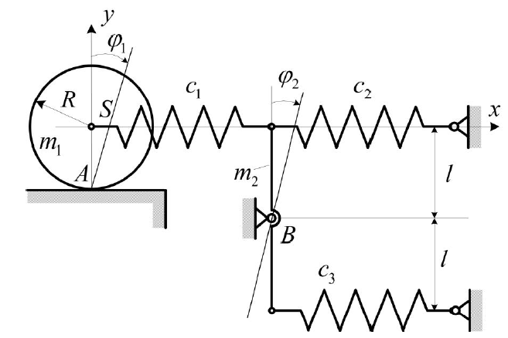

**2/ Exercise:**

Spatial bevel gear mechanism is given with its mechanical model with ⍵01 and ⍵03 angular velocity inputs.

* Please construct the angular velocity diagram.
* Please determine the ratio of i14 parametric.

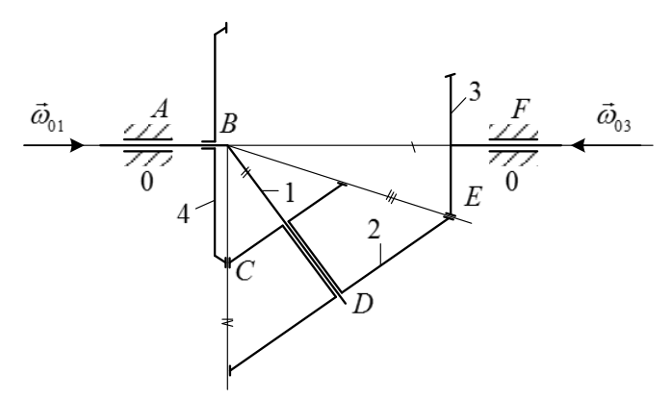

**3/ Exercise:**

For-bar linkage mechanism is given with their length of thge AB, BC CD rods and degrees. Furthermore the angular speed of the AB rod is known.

*, , ,, , .*



* Please calculate the velocity of the B and C points.
* Please calculate the angular velocity of the 2nd and 3rd rods.
* Please determine the degree of freedom (DOF) of the mechanism.