Mérés és irányítástechnika I-II.

- Simplify and realize the following binary equation with relays and NOR/NOR logic gates: F4 (D,C,B,A)= Pi(2,3,4,6, x9, x10, 12,14)
- Calculate the critical gain of the following equation with Routh Hurwitz stability criteria. Y(s)= 2/((1,1s+2,2)*(2,1s+1,1)*(2,2s2+1s+1)).
- How much cobalt strain gauge resistance in case of 2 mm per meter elongation? Nominal resistance: 600 Ohm, elongation factor: 2
- Hall sensor measuring range 5 A, Relative measurement error <± 0.4%.
Calculate the relative error of the measurement in case of 4.7 A and 0.7 A.
- Fill out the charts of the table according to the operation. Determine the function relation F = f (A, B).

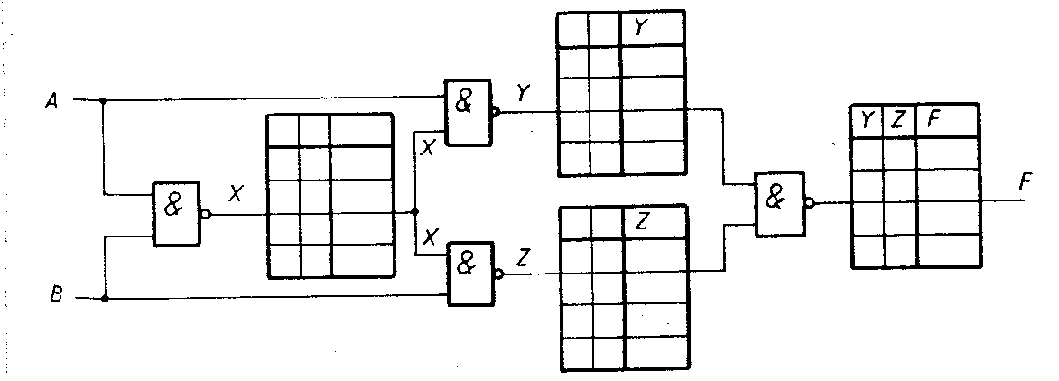

Mechatronics I-II

- Should I use a throttle valve? The parameters of hydraulic cylinder, maximum allowed piston speed: vmax = 0.2 m/sec? Stroke length: L = 300 mm, Max. working pressure: p = 120bar, Max. forming force: F = 20,000N, Liquid flow: q = 23.25 dm3/min.
- A passenger car must be lifted with a jack. Car weight is 1500 kg. What should be the force F at the piston, if A1 = 0.4 [dm2], A2 = 0.12 [m2]? How much should it be
the surface of the piston A2 if we have only 100 N force?
- Calculate air consumption of the pneumatic cylinder forward and back direction. Stroke length: 100 mm, Piston diameter: 20 mm, Piston rod diameter: 8 mm, Max. working pressure: 6 bar.
- Calculate, in ideally how much weight can be lifted with a pulling hydraulic cylinder. Parameters Stroke length: 300 mm, Piston diameter: 30 mm, piston rod diameter: 16 mm, working pressure: 35 bar.
- How much should be the internal diameter of the tube, in case of with a 4 l/min flow rate of 3 m/s speed can be achieved??

Programming and digital technics (I) I

- Change Roman numerals CXXXIX (Roman Number) to binary number and simplify. Please draw/relalize with true table, Relay circuit, K-Map, Not-And-Or gates.
- Please make code converter, Stibitz-Aiken 0-7. Simplify and make relay circuits.
- Please convert F(A,B,C,D)=221 function to F(D,C,B,A).

Basics of Mechatronics

Adott az ábrán látható mechanizmus. ω_{A} = 1 rad/sec.
- Írja fel a mechanizmus rövid szerkezeti képletét és a kényszerek szabad elmozdulásának paraméteres egyenletét!
- Írja fel az ω_{A} vektorát!
- Határozza meg a mechanizmus I pontjának a sebességvektorát!
- Határozza meg a mechanizmus BI tagján lévő J pont pillanatnyi sebességvektorát!
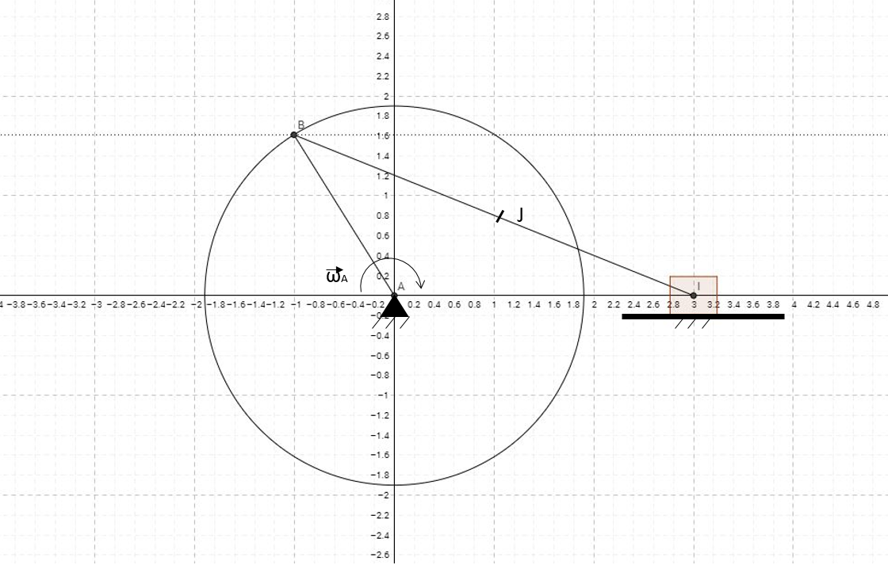

Adott az ábrán látható mechanizmus. v_{I} = 1 m/sec.
- Írja fel a mechanizmus rövid szerkezeti képletét és a kényszerek szabad elmozdulásának paraméteres egyenletét!
- Határozza meg a mechanizmus B pontjának a sebességvektorát!
- Írja fel az ω_{A} vektorát!
- Határozza meg a mechanizmus BI tagján lévő J pont pillanatnyi sebességvektorát!
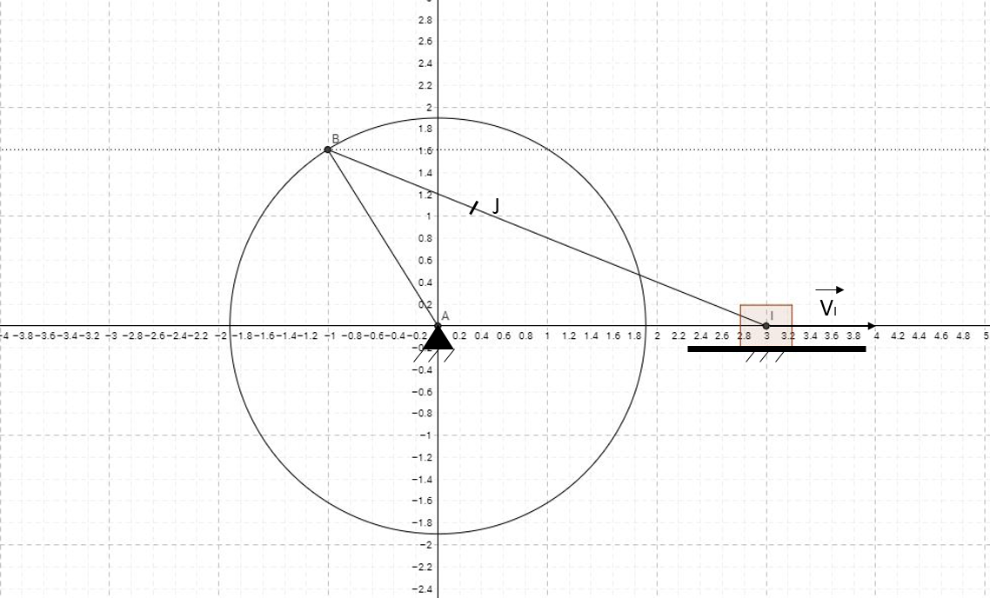

Adott az ábrán látható mechanizmus. ω_{A} = 1 rad/sec.
- Írja fel a mechanizmus rövid szerkezeti képletét és a kényszerek szabad elmozdulásának paraméteres egyenletét!
- Írja fel az ω_{A} vektorát!
The basic data of the two-dimensions mechanism below are. The magnitude of angular velocity of link AB is ω_{A} = 1 rad/sec. The geometric parameters are shown in the figure.
1. Write the short structural formula of the mechanism and the parametric equation free displacement of constraints!
2. Write the vector ω_{A}!
3. Determine the velocity vector of point I of the mechanism.
4. Determine the instantaneous velocity vector of the J point at the BI tag of the mechanism!

The basic data of the two-dimensions mechanism below are. The magnitude of angular velocity of link AB is ω_{c} = 1 rad/sec. The geometric parameters are shown in the figure.
1. Write the short structural formula of the mechanism and the parametric equation free displacement of constraints!
2. Write the vector ω_{C}!
3. Determine the angular velocity of the AB member of the mechanism!
4. Determine the instantaneous velocity vector of the J point on the BD tag of the mechanism!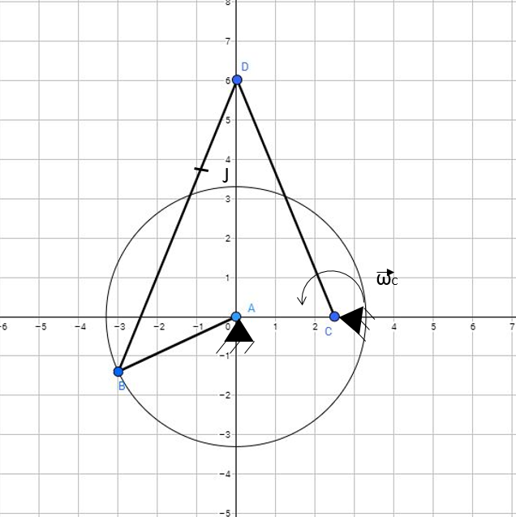

Draw the BOND GRAPH model of the mechanical system! Use standard notation.
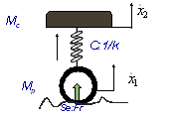
Draw the BOND GRAPH model of the mechanical system! (Use standard notation.)
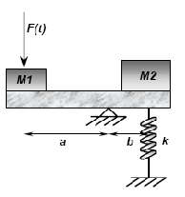
Draw the BOND GRAPH model of the mechanical system! (Use standard notation.)
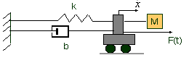

Garage Door controlling
Create a program in Ladder Diagram which controls a garage door with the following method
The open/close button is only allowed to operate, when the motor is in off state.
The closing/opening motor will be energized to open/close the gate.
In case of opening, the motor has to operate until the full open sensor fires.
In case of closing the motor has to energize until the fully closed end switch sensor fires.
Also exist another sensor (infra red). When during operation of the motor this sensor fires, The motor should stop immediately.

Reservoir system control/simulate.
Create a Ladder Diagram for the following reservoir control.
We are loading a water tank, by operating a water pump, and unloading with the opening of the output tap. There are two sensor exist on the tank, one high level (HL) and one low level (LL).
The operation of the pump is the following:
When the water from the tank is fully unloaded (HL = 0 and LL= 0 ), than the pump will be switched on, until the tank is fully loaded (HL=1 and LL=1)
In case of a fault sensor operation (LL = 0 and HL=1) blink an error indication lamp (1s period)
A flow sensor is also built into the system to prevent the dry operation of the pump. If the sensor is not firing for more than 4s, than the pump has to be stopped immediately, and the error lamp should light on continuously.

The drawing shown below is pictorial representations of real mechanism (without electric energy) that are commonly encountered. (hand-operated mechanical water pump)
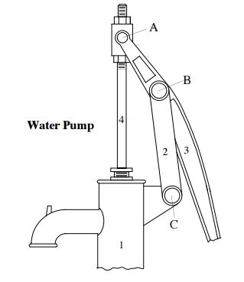 | Make a freehand sketch of the kinematic schematic representation (model) of mechanism.
- Calculate number of degrees of freedom!
- Make a freehand sketch of the BOND GRAPH representation of water pump (use the correct effort and flow description)!
- Write the dynamic equations of the elements and junctions of water pump!

In a standing cylindrical tank (diameter is 4 m) level control is carried out. The level is measured with a 0.8 m measurement limit transmitter. The output flow is transported with a pump, which ensures constant 0.6 bar pressure difference. The fluid is water. In the output tube there is a control valve with the following features:
linear characteristic, kvs= 32 m3/h,
In this circle there is a P control, with Ap= 22. The liquid is water.
In the steady state the level in the tank is 1.2 m and the flow rate is 11 m3/h.
- How much can be the range of the input flow rate in order to the controller hold constant level in time?
- How can change the level in the tank? (Which is the lower and the upper limit?)
Hot water is produced in a perfectly mixed, open water tank with direct steam injection. In the initial stationary state with 25 kg/h steam flow the temperature is increased from 17 °C to 75 °C. Suddenly the steam flow is turned off. Because this reason the water’s temperature start to decreasing as shown in the following table:
i [min] | 0 | 2 | 4 | 8 | 12 | 16 | 20 | 25 | 30
t2 [°C] | 75 | 69.5 | 64.6 | 56 | 48.9 | 43 | 38.1 | 33.2 | 29.4
- Convince that the shape of transfer function of heat exchanger is $\frac{A}{T∙s+1}$.!
- Determine the A and T!
- After turned off the steam injection, the new steady state is waited. After it, the steam flow is turned on, which is 45 kg/h. Give the outlet temperature as function of the time! After it, determine that when will be 75°C the water temperature in the water tank.

Determine the critical circle amplification according to Routh-Hurwitz stability criterion of this equation Y(s)= 20/((1,05s+2)*(1,1s+2)*(1,2s2+2s+1))

Realize the simplest formula and implement relay circuit and NAND / NAND gates logic the F⁴(X,Y,Z,K) four variable prime number function.

Programmable logic controllers I
- Discribe at least six logic operators that can be used in PLC programming (symbols, algebra, ladder diagrams).

- Discribe Modbus, Profibus, CANbus network protocols (advantage, disadvantage, transmission media, application field), and the OSI Model’s seven layers.

- Design a PLC Ladder program to control a garage door:
The garage door should open when the „Opening button” is pressed, and close when the „Closing button” is pressed. If the „Photocell” sensor signalizes to have a obstruction under the door, it should stop the closing of the door but not the opening. While the „Photocell” signalizes to have an obstruction, closing the door must not be started. The door-mover motors are stopped by limit switches. If two limit switches signalize at the same time, the system should signalize error and stop moving! Moving can only continue after abolishment of the error! Describe the Input & Outputs!

- Design a PLC Ladder program to control crosswalk lamps.
In initial state the vehicles can move on. If a pedestrian wants to cross the road, they have to push the button. Then the vehicles get a yellow, then red signal, then the pedestrian gets green, then flashing green signal, than the vehicles get red-yellow, then green signal.
Describe the Input & Outputs!

- Design a PLC Ladder program to control motors!
There are two motors. The MOTOR2 can only start when, after MOTOR1 has already started. We observe the motor’s temperature with thermic sensors. The OFF button acts like a dominant eraser. Discribe the Input & Outputs!

