Motorcycle Powertrain Development Workshop at the
Faculty of Engineering, UD

The course is focusing on the construction of a motorcycle’s powertrain, analyzing its operation and redesigning some parts of it to develop a racing motorcycle. The program contains the basics of motorcycle constructions; designing and modeling different parts of the engine; workshop practice; rapid prototyping, additive manufacturing; material tests and diagnostics. At the end of the course the motorcycle engine will be assembled with the redesigned and produced parts and tested.

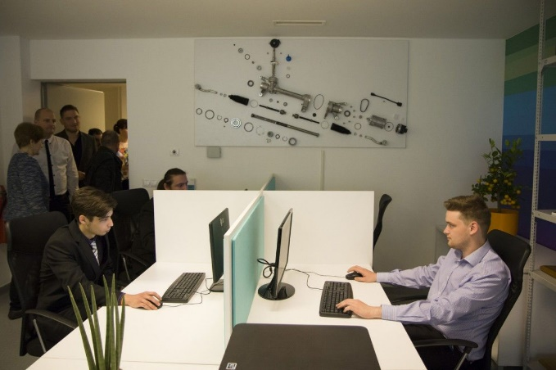

Week 1
 | Monday | Tuesday | Wednesday | Thursday | Friday
1 | Welcome at the Faculty of Engineering, UD | Power transmission of motorcycles | Power transmission of motorcycles | Dynamical Analysis of drivetrain elements | Concept Selection and Embodiment Design
2 | Welcome at the Faculty of Engineering, UD | Power transmission of motorcycles | Power transmission of motorcycles | Dynamical Analysis of drivetrain elements | Concept Selection and Embodiment Design
3 | Introduction to the key issues of the development of a racing motorcycle | Methodologies and Techniques for Reverse Engineering | CAD Modeling of powertrain parts | Engineering Design Methods | Concept Selection and Embodiment Design
4 | Problem statement, Gathering requirements,  Success factors | Methodologies and Techniques for Reverse Engineering | CAD Modeling of powertrain parts | Engineering Design Methods | Concept Selection and Embodiment Design
5 | Disassembly of the motorcycle Powertrain | Reverse Engineering of the powertrain | CAD Modeling of powertrain parts | Workshop, Brainstorming | Engineering Optimization Methods and Applications
6 | Disassembly of the motorcycle Powertrain | Reverse Engineering of the powertrain | CAD Modeling of powertrain parts | Workshop, Brainstorming | Engineering Optimization Methods and Applications

Week 2
 | Monday | Tuesday | Wednesday | Thursday | Friday
1 | Finite Element Analysis of the designed parts | Rapid Prototyping, Additive Manufacturing | Designing of manufacturing processes of vehicle parts | Machining the designed parts | Workshop, Vibration measurements
2 | Finite Element Analysis of the designed parts | Rapid Prototyping, Additive Manufacturing | Designing of manufacturing processes of vehicle parts | Machining the designed parts | Workshop, Vibration measurements
3 | Detail Design with Parametric CAD System | Designing of manufacturing processes of vehicle parts | Material testing of powertrain parts | Machining the designed parts | Workshop, Vibration measurements
4 | Detail Design with Parametric CAD System | Designing of manufacturing processes of vehicle parts | Material testing of powertrain parts | Machining the designed parts | Workshop, Vibration measurements
5 | Rapid Prototyping, Additive Manufacturing | Designing of manufacturing processes of vehicle parts | Material testing of powertrain parts | Condition Monitoring and Measurement Techniques | Assembly of the powertrain parts
6 | Rapid Prototyping, Additive Manufacturing | Designing of manufacturing processes of vehicle parts | Material testing of powertrain parts | Condition Monitoring and Measurement Techniques | Testing the developed motorcycle powertrain

