Electrotechnics

Draw the transistors electrical symbol, in-output characteristics, write the transistor equations, and explain the nomenclatures!

Draw the MOSFET’s and JFET’s electrical symbols, in-output characteristics, write the equations, and explain the nomenclatures.

Explain the types of power amplifiers.

Explain the types of operation amplifiers.

Exercise: Calculate the circuit’s Active, Reactive and Complex Power and the Power Factor. Draw the Voltage and Current time functions in coordination system.

U(t)=17 sin(314t+22°)V
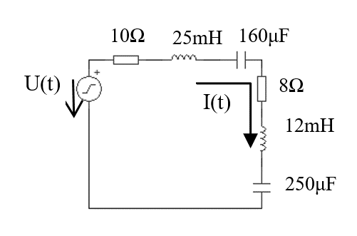

What types of basic circuits in Figure and how much the circuit total gain value?

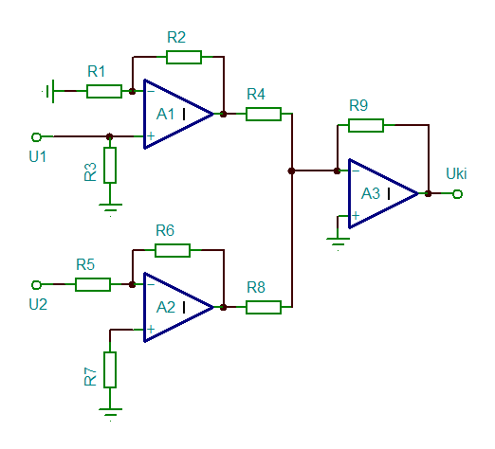
R₁=100Ω, R₂=10kΩ, R₃=100Ω, R₄=200Ω, R₅=1kΩ, R₆=50kΩ, R₇=1kΩ, R₈=200Ω, R₉=15kΩ, U₁=U₂
A₁……………….type Op Amp
A₂………………. type Op Amp
A₃………………. type Op Amp

