System of Citations and References and Rules of Handling References
Fundamental rules of bibliography
Its definition:
A bibliographical reference is the collection of precise and sufficiently detailed data that enables a publication (or a part of it) to be identified.
Types of references:
- Reference: an author’s work is mentioned, his/her thought is adapted, and however, it is not a verbatim text.
- Citation: Adapting a word-for-word part of an author’s text.
‘A citation is a short form of bibliographical references that is indicated in round brackets either the text or at the end of the whole text. A citation enables the identification of a publication from where a citation or an idea is originated and determines its precise location in the resource.
- Adaption: Adaption means the application of a published work in other works to such an extent that goes beyond citation.
In any reference failing to identify the resource precisely is infringement of copyright (plagiarism).

How to indicate a reference?
Purpose of Reference:
To identify, to recognize, to research the cited book or journal etc., furthermore to simplify the application of scientific and educational literature with a single procedure.
Form of Reference:
Detailed reference: all the relevant bibliographical data of the document; it is applied as a book review, a resource publication.
E.g.: Sahin YILDIRIM, Géza HUSI, Dr: Design of proposed hybrid neural network controller for position control of a four-legged walking robot. / ed. Géza HUSI./ - 2nd revised enlarged ed. – BP.: Akadémia Kiadó, 2007, p 336 (Serial: Researches in Mechatronics) – bibliography p256-332 –ISBN963 05 4766
Abridged reference: only those data are provided that are essential for identification.
E.g.: Sahin YILDIRIM, Géza HUSI, Dr: Design of proposed hybrid neural network controller for position control of a four-legged walking robot. – 2nd revised enlarged ed. – 2007 –ISBN963 05 4766
An example of bibliography frequently applied in engineering:
Passage from a paper, a book, etc.:
A neural-network-based control technique has been proposed for stabilizing a base excited inverted
pendulum [1]. The pendulum has two degrees of rotational freedom and the base-point moves freely in the three-dimensional space. In their investigation, additionally, the developed controller does not require measurement of the base-point accelerations, which are difficult to obtain. The work presented here benefits practical problems such as the study of stable locomotion of human upper body and bipedal locomotion. A control strategy has been proposed allowing us to perform the dynamic walking gait of an under-actuated robot even if this one is subjected to destabilizing external disturbances [2]. In their proposed control strategy is based on two stages. The first one consists of using a set of pragmatic rules in order to generate a succession of passive and active phases allowing us to perform a dynamic walking gait of the robot. A hybrid learning architecture based on reinforcement learning and self-organizing neural networks for online adaptively has been presented [3]. The hybrid concept integrates different learning methods and task-oriented representations as well as available domain knowledge. Their proposed concept is used for RL of control strategies on different control levels on a walking machine.

List of references in a paper, a book, etc.:
List of references:
- Wu, Q. Sepehri, N., and He, S., 'Neural inverse modeling and control of a base-excited inverted pendulum', Engineering Applications of Artificial Intelligence 15, 2002, 261-272.
- Sabourin, C., and Bruneau, O., 'Robustness of the dynamic walk of a biped robot subjected to disturbing external forces by using CMAC neural networks', Robotics and Autonomous Systems 51, 2005, 81-99.
- Ilg , K., Miihlfriedel, B. and Dillmann, R., 'Hybrid learning concepts based on self-organizing neural networks for adaptive control of walking machines', Robotics and Autonomous Systems 22, 1997, 317-327
Special rules of references from Internet:
- Géza Husi Application of the methods of quality management systems for analysing of the police of the republic of Hungary
List of references:
http://e-articles.info/e/a/title/APPLICATION-OF-THE-METHODS-OF-QUALITY-MANAGEMENT-SYSTEMS/ downloaded: 2009-10-03

Special rules of referencing figures:
The source must be indicated in case of adapting
An example for an adapted figure:
In Lean management the essential elements of unproductive procedures have to be lived with whose number, quantity, time have to be decreased while the unessential elements of the procedure have to be terminated. On the basis of the analyses in the manufacture of a product 95% of expenditure of the time required includes unproductive work elements.
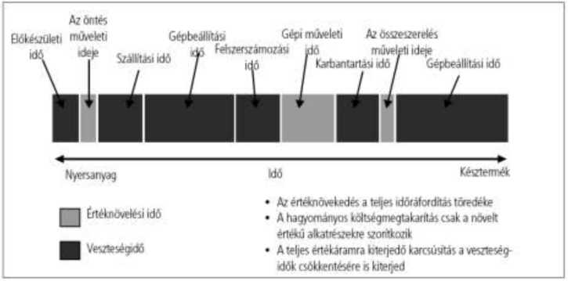

Figure 1 Loss of Productive Work (source: [5])
This very high number is due to the fact that before the start of production expectations are not clarified precisely therefore production will be improvised and workers will also be wrong in implementing a process.
In list of references:
[5.] Petrók, J. (2007 1-2). A Toyota Way. A jövő járműje 2007. , 10.
[6.] Sekine, K. (1999). Cellular Manufacturing Learning Package. Andover, Hants, SP10 5BE,
UK: Productivity Press Shopfloor serie.
[7.] Sipos István Husi Géza. (2007). Az emberi tényezők szerepének meghatározása a légijárművek karbantartásának minőségbiztosításában. Debreceni Műszaki Közlemények 2007/1 , HU ISSN 1587 - 9801 , 45.

An example for a figure from Internet
An error: every occurrence that results the repetition of an element of the process, moreover every event of a process which result cannot be conveyed to the forthcoming process element or the customer.
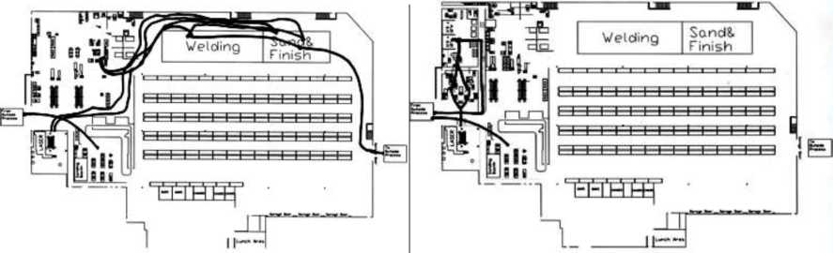
Figure 2 The way of an unimportant component in the production hall before introducing Lean (left side) and after that (right side) (source: http://leanmanufacturingconsulting.com/casestudies_fabrication_cell.html)
Figure 1 indicates the way of an unimportant element. It visualizes the production hall before and after the introduction of Lean.
A reference is not required in the list of references in this case.

An example for a restructured figure:
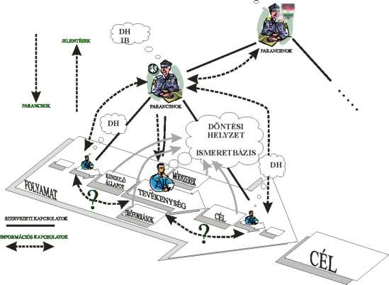
DS (DH)= Decision-Making Situation
KB= Knowledge Base

Figure 3 Individual Decision Support System (Csemy’s model [138] completed with features of the police and restructured)
In list of references:
[138] Dr. László Cserny Organizational Decision Support Ph.D. dissertation. Budapest University of Economic Sciences and Public Administration, Budapest 2000

