Thesis

Student’s name
2020.

University of Debrecen, Faculty of Engineering
Mechatronical Engineering (MSc)

Student’s name
THE TOPIC OF THE THESIS

Supervisor: Tutor
External consultant: Consultant engineer

Head of Department: Géza Husi Ph.D. habil., associate professor

2020

Thesis Application Sheet (original, signed by the head of department)
Thesis Evaluation Sheet (signed by the supervisor and the head of department).

Plagiarism statement
I, the undersigned Student’s name (Neptun code: ABCDEFG) by signing the present statement declare that the thesis entitled

TITLE OF THESIS
- hereinafter called thesis - is my independent work. In the course of making the thesis I conformed to the rules of Act No. LXXVI of 1999 on Copyright, and the regulations of the University of Debrecen regarding the principles of making a thesis, particularly in respect of the references and citations .
I declare moreover that in the course of making the thesis, concerning the independent work I did not mislead my supervisor. I did not make use of any forbidden support, and I did not submit the work as a thesis in any other educational institution previously.
By signing the present statement I take notice of the fact that the University of Debrecen has the right to deny the acceptance of the thesis and to take disciplinary action against me if it is demonstrably not my intellectual creation, if any infringement of copyright falls under suspicion, or I have already submitted the thesis to another educational institution.
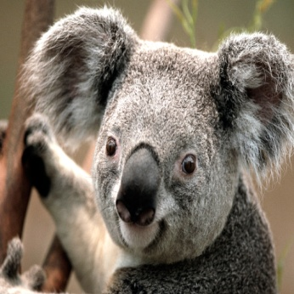
The denial of the acceptance of the thesis and the disciplinary procedure do not affect other legal consequences (Civil Law, Law of Petty Offence, Criminal Law) caused by the infringement of copyright.

signature
Student’s name
day, month, year, Debrecen

Table of contents
(unnumbered)

Table of contents
Plagiarism statement 6
Table of contents 7
Summary in English 8
Introduction 9
1. Theoretical summary 10
2. Main chapter 11
2.1. The length of the thesis 11
2.2. Page format 11
2.3. Titles, subtitles 11
2.3.1. Third-level title sample 11
2.4. Symbols, Equations, Figures 12
2.4.1. Formulas 13
2.4.2. Mathematical variables 13
2.4.3. Figures captioning 13
2.4.4. Tables 14
2.4.5. Units 14
2.4.6. Abbreviations 14
2.4.7. Commercial products 14
2.4.8. Photoes 14
2.4.9. Graphs 14
3. Summary 15
4. References 16
Appendix 17

Summary in English
(unnumbered)
The abstract without reading the whole paper must be a clear specification.

Introduction
(unnumbered)
Introduction of the thesis (1-3 pages)
Representation of the task, the purpose of the thesis, justification of the task, a short summary about the structure of the thesis

Theoretical summary
Literary and theoretical summary of the thesis topic (10-30 pages):
Theoretical summary is a constructed summary on the basis of the latest publications on the thesis topic that introduces what theory others’ previously presented, research results, experiments, engineering creations were applied to the thesis. Theoretical summary must include the required theoretical derivations (with right references), the familiar scientific and/or engineering results. Theoretical summary must be written on the basis of at least 10 specialized books, articles, conference articles of which a maximum of one third can be internet resource. (These publication data bases can be entered from computers registered to the university network: IEEExplore, eisz, Scopus, Science direct , data base of the library.)

Main chapter
The title of this chapter is optional.
Here you need present the work, plans, detailed descriptions of the solved problems, evaluation of the chosen solutions of the option carried out.
  - The length of the thesis
The length of the thesis must be about 90 pages (from the cover but not included the appendix) line spacing is 1.5, with about 55-60 characters (including space characters) in a line. The minimum length of the thesis must be 70 pages, the maximum must be 110 pages.
In the thesis the candidate must take care of using precise language and academic style. Variables of mathematics and physics must be displayed by cursives in the text and figures. Vector quantity in physics must be displayed by bold cursives, tensor quantity must be bold.

Page format
Font: Cambria, normal, size 12, 1,5 distance.

Titles, subtitles
Divide your thesis to main and sub-chapters, and use paragraphs within it. The numbering of the chapters follow the decimal system. The first rule for titles that is always positioned in the left margin, be bold and capital letters. If the title in on the top, left two empty lines before and after the title.
Formatting the titles like in the 2. Main chapter.
Second level titles like in the 2.3 Titles, Subtitles.
Third level subtitles: as 2.3.1 Third-level title sample

Third-level title sample
Paragraphs: In the text there are no paragraphs, each line on the left margin should begin. The format of the lines is justified.

Symbols, Equations, Figures
Use the symbols from the charset: €, α, ϕ

Formulas
The formulas should be placed in row and centre. The formulas must be equipped with Arabic numbering in brackets (1), which must be adjusted to the right page margin. In the text the mathematical variables, for example x, y should be in italics. Long equations should be written in two rows.

Mathematical variables
Font: Cambria Math, italic, 12, simple distance, at the end of the line number the marked formula:
$f\left(x\right)=a_{0}+\sum_{n=1}^{∞}{\left(a_{n}\cos{\frac{nπx}{L}}+b_{n}\sin{\frac{nπx}{L}}\right)}$ (1.)
$x=\frac{-b±\sqrt{b^{2}-4ac}}{2a}$ (2.)

Figures captioning
The numbering should be continuous. To each figure must be have a caption which cannot be wider than the figure itself. The figures have to make on PC. Write the figure captions under the pictures, in case of tables write above them. Proposed figures made of other documents or applications as images insert in the thesis, hence the figure dod not “fall apart”.
The inscriptions on the figures must be readable.
Figures: numbered on the bottom centre Cambria, normal, size 10:
1. Fig. Building mechatronical research centre
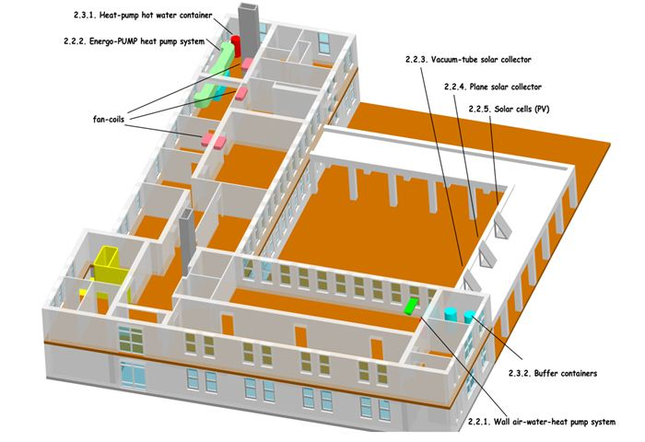

Tables
The tables should be independent from the text, the numbering should be ongoing.Each column must be include well defined symbols and units.
Numbered on the top right Cambria, normal, size 10
1. TableEmpty tble template
ω (angular speed)
[1/s or s⁻¹]

Units
Comply with the International System of Units.

Abbreviations
Avoid the abbreviation of the words, bearing in mind the possible difficulities of interpretation to the reader.At the first time of using an acronym write the whole version. For example Low Pass Filter (LPF).

Commercial products
Avoid the trade products manufacturer’s name, unless it is unavoidable.

Photoes
Both black and white and color pictures allowed, but must be identical contrast.

Graphs
The ordinate, the abscissa explanation, measurement units and other required labels should be provided.

Summary
Evaluation of the results, introducing further possibilities of improvement.

References
At the end of the thesis a numbered bibliography should be placed. Use single spacing and left one empty line between titles. The format is the next: Name of the author(s): Title, name of the journal title, year of publication, number of pages. Just the overall format will be accepted!
Other resources must be marked to make them easy to identify. Pay attention to the Internet links! After all Internet’s data should be placed the URL’s exact date, since the contents of the web pages can be change.
Setting the IEEE Word automatically creates a list of good literature!
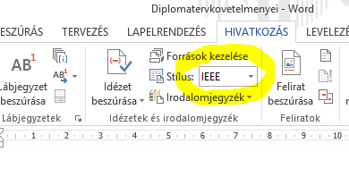

Appendix
(unnumbered) Any detailed calculations, data sheet sources. In the CD/DVD attachment places the full paper and all the necessary attachments, resources and documentation.
Only those documents can be put in the appendix which the study refers to or necessary for understanding.

