Mechatronics Comprehensive Exam
2018.
Written exam

Name:
Neptun code:

Programmable logic controllers I.

3. Design a PLC Ladder program to control a garage door: The garage door should open when the „Opening button” is pressed and close when the „Closing button” is pressed. If the „Photocell” sensor signalizes to have a obstruction under the door, it should stop the closing of the door but not the opening. While the „Photocell” signalizes to have an obstruction, closing the door must not be started. The door-mover motors are stopped by limit switches. If two limit switches signalize at the same time, the system should signalize error and stop moving! Moving can only continue after abolishment of the error! Describe the Input &Outputs!

4. Design a PLC Ladder program to control crosswalk lamps.In initial state the vehicles can move on. If a pedestrian wants to cross the road, they have to push the button. Then the vehicles get a yellow, then red signal, then the pedestrian gets green, then flashing green signal, than the vehicles get red-yellow, then green signal. Describe the Input & Outputs!

5. Design a PLC Ladder program to control motors! There are two motors. The MOTOR2 can only start when, after MOTOR1 has already started. We observe the motor’s temperature with thermic sensors. The OFF button acts like a dominant eraser. Describe the Input & Outputs!

6. Create a Ladder Diagram for the following reservoir control.
We are loading a water tank, by operating a water pump, and unloading with the opening of the output tap.
There are two sensor exist on the tank, one high level (HL) and one low level (LL).
The operation of the pump is the following:
When the water from the tank is fully unloaded (HL = 0 and LL= 0 ), than the pump will be switched on, until the tank is fully loaded (HL=1 and LL=1)
In case of a fault sensor operation (LL = 0 and HL=1) blink an error indication lamp (1s period)
A flow sensor is also built into the system to prevent the dry operation of the pump. If the sensor is not firing for more than 4s, than the pump has to be stopped immediately, and the error lamp should light on continuously.

Measurements and automatics I-II.
- Simplify and realize the following binary equation with relays and NOR/NOR logic gates:F4 (D,C,B,A)= Pi(2,3,4,6, x9, x10, 12,14).

- Calculate the critical gain of the following equation with Routh-Hurwitz stability criteria. Y(s)= 2/((1,1s+2,2)*(2,1s+1,1)*(2,2s²+1s+1))

- How much cobalt strain gauge resistance in case of 2 mm per meter elongation? Nominal resistance: 600 Ohm, elongation factor: 2

- Hall sensor measuring range 5 A, Relative measurement error <± 0.4%.
Calculate the relative error of the measurement in case of 4.7 A and 0.7 A.

- Fill out the charts of the table according to the operation. Determine the function relation F = f (A, B).

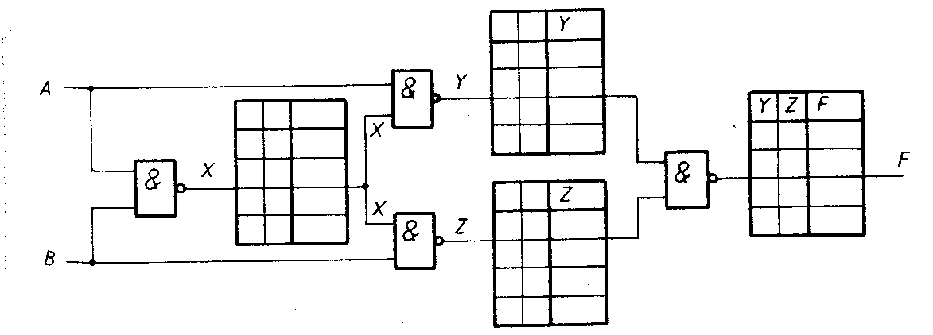

6. Determine the critical circle amplification according to Routh-Hurwitz stability criterion of this equation Y(s)= 20/((1,05s+2)*(1,1s+2)*(1,2s²+2s+1))

Mechatronics I-II.

- Should I use a throttle valve? The parameters of hydraulic cylinder, maximum allowed piston speed: vmax = 0.2 m/sec? Stroke length: L = 300mm, Max. working pressure: p = 120bar, Max. forming force: F = 20,000N, Liquid flow: q = 23.25dm3/min.

- A passenger car must be lifted with a jack. Car weight is 1500 kg. What should be the force F at the piston, if A1 = 0.4 [dm2], A2 = 0.12 [m2]? How much should it be the surface of the piston A2 if we have only 100 N force?

- Calculate air consumption of the pneumatic cylinder forward and back direction. Stroke length: 100 mm, Piston diameter: 20 mm, Piston rod diameter: 8 mm, Max. working pressure: 6 bar.

- Calculate, in ideally how much weight can be lifted with a pulling hydraulic cylinder. Parameters Stroke length: 300 mm, Piston diameter: 30 mm, piston rod diameter: 16 mm, working pressure: 35 bar.

- How much should be the internal diameter of the tube, in case of with a 4 l/min flow rate of 3 m/s speed can be achieved?

Programming and Digital Techniques I.-II.

7. Change Roman numerals CXXXIX (Roman Number) to binary number and simplify. Please draw/realize with true table, Relay circuit, K-Map, Not-And-Or gates.

8. Please make code converter, Stibitz-Aiken 0-7.Simplify and make relay circuits.

9. Please convert F (A,B,C,D)=221 function to F(D,C,B,A).

10. Realize the simplest formula and implement relay circuit and NAND / NAND gates logic the F⁴(X,Y,Z,K) four variable prime number function.

11. Prepare a C Like function, what is able to select modulo 3 numbers out of 10 dimension integer array.

12. Prepare a C like function, what is able to sort 10 dimension floating array as ascending numbers .

Electrotechnics and electronics I-II.
1. Calculate the branch currents of the circuits using the
- Kirchhoff equations
- Mesh analysis
- Nodal analysis
Determine the Norton and Thevenin equivalents of the circuit between A and B connections. Calculate the value of R_{load} and P_{max.}

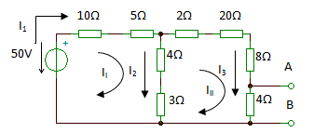

2. Calculate the currents of the circuit. Draw the Voltage and Current graphs in function of time in Descartes-coordinate system (with correct scaling). Calculate Active Power, Reactive Power and Complex Power. Calculate and draw the effective values of Current and Voltage.
V(t)=20 sin(314t+12°) [V]
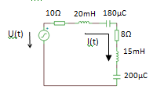
3. Determine the operating range of the transistor in the shown circuit (operating condition). Calculate the I_{B} I_{C} and V_{CE} values (Voltage and Current of the operating point (working point)).
The values of the transistor B=100, V_{BE}=0.7V, V_{CES}=0.2V
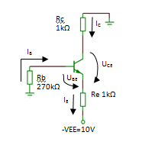

-VEE=10V

4. Calculate the voltage gain of the inverting operation amplifier. Calculate the phase shift of the in and out voltages. Calculate the values of the input resistance and the R3 resistor.
R1=10kΩ R2=120kΩ
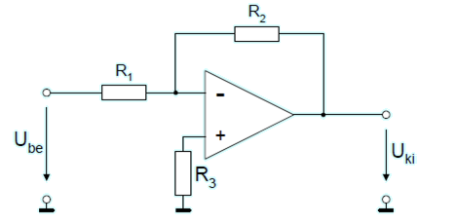

5. Calculate the parameters of the amplifier. The Input voltage is 10mV. Calculate the voltage on the load resistor (R_{T}). The values of the transistor are B=130, V_{BE}=0.6V. The capacitors work as short-circuit in the frequency range of the amplifier.
U(t)=
10mV
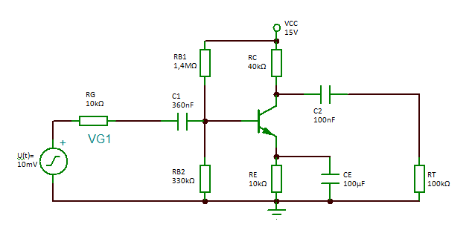

Basics of Mechatronics
1. The basic data of the two-dimensions mechanism below are. The magnitude of angular velocity of link AB is ω_{A}= 1 rad/sec.
The geometric parameters are shown in the figure.
1. Write the short structural formula of the mechanism and the parametric equation free displacement of constraints!
2. Write the vector ω_{A}!
3. Determine the velocity vector of point I of the mechanism.
4. Determine the instantaneous velocity vector of the J point at the BI tag of the mechanism!
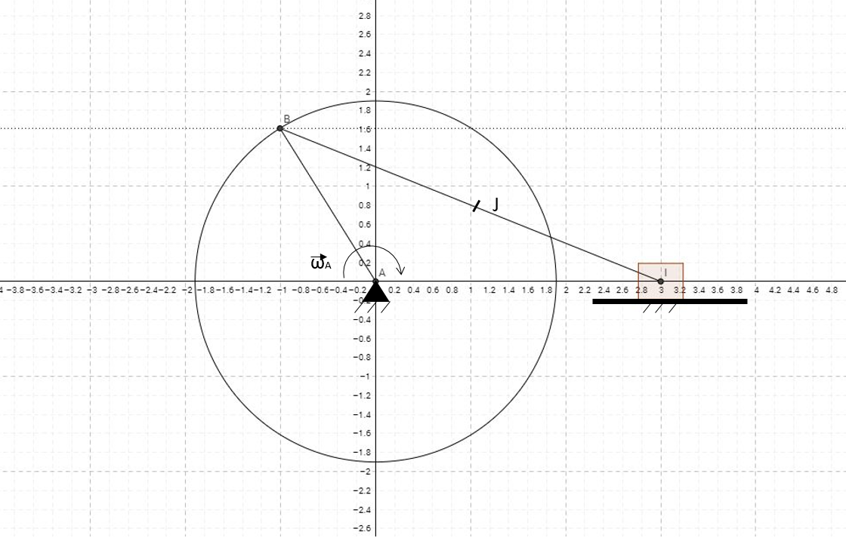

2. The basic data of the two-dimensions mechanism below are. The magnitude of angular velocity of link AB is v_{I}= 1 m/sec.
The geometric parameters are shown in the figure.
1. Write the short structural formula of the mechanism and the parametric equation free displacement of constraints!
2. Determine the velocity vector of point B of the mechanism.
3. Write the vector ω_{A}!
4. Determine the instantaneous velocity vector of the J point at the BI tag of the mechanism!
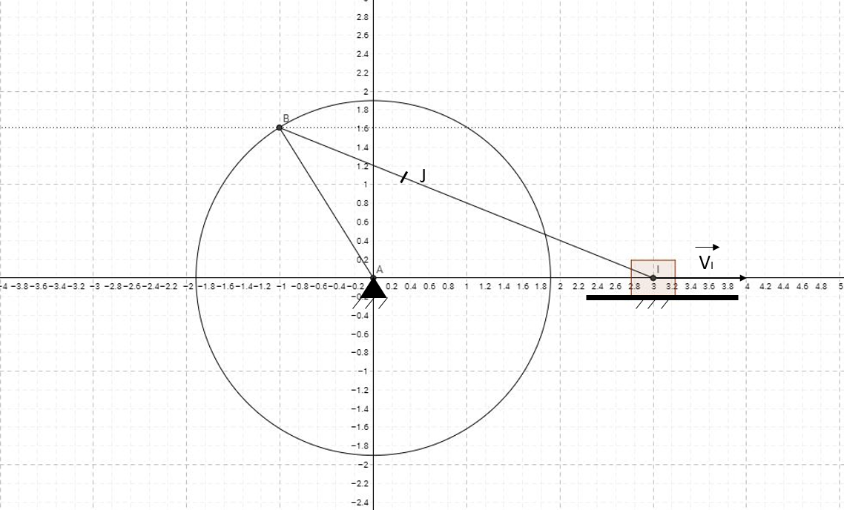

3. The basic data of the two-dimensions mechanism below are. The magnitude of angular velocity of link AB is ω_{c}= 1 rad/sec. The geometric parameters are shown in the figure.
1. Write the short structural formula of the mechanism and the parametric equation free displacement of constraints!
2. Write the vector ω_{C}!
3. Determine the angular velocity of the AB member of the mechanism!
4. Determine the instantaneous velocity vector of the J point on the BD tag of the mechanism!

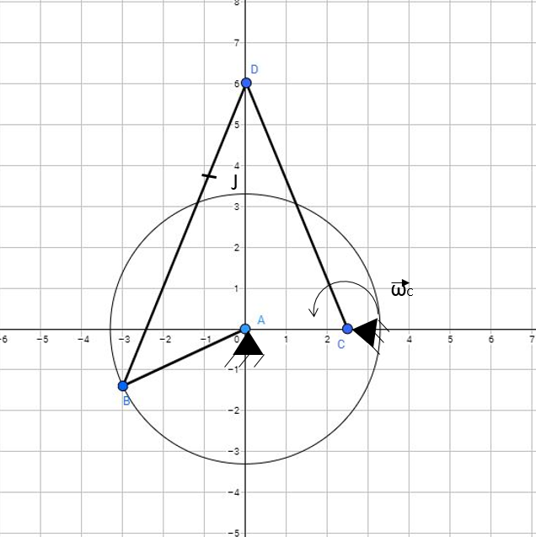

4. The basic data of the two-dimensions mechanism below are. The magnitude of angular velocity of link AB is ω_{A}= 1 rad/sec. The geometric parameters are shown in the figure.
1. Write the short structural formula of the mechanism and the parametric equation free displacement of constraints!
2. Write the vector ω_{A}!
3. Determine the angular velocity of the CD member of the mechanism!
4. Determine the instantaneous velocity vector of the J point on the BD tag of the mechanism!

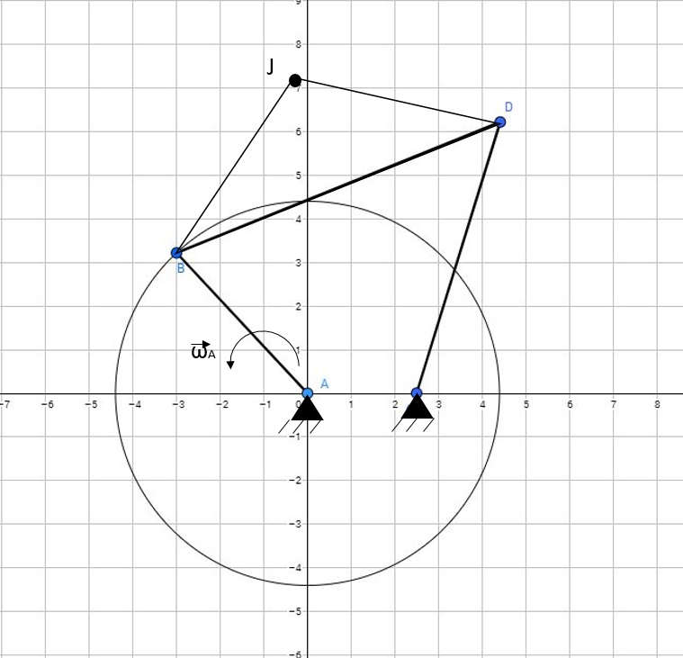

C

5. Draw the BOND GRAPH model of the mechanical system! (Use standard notation.)
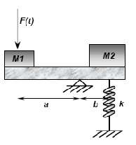

6. Draw the BOND GRAPH model of the mechanical system! (Use standard notation.)
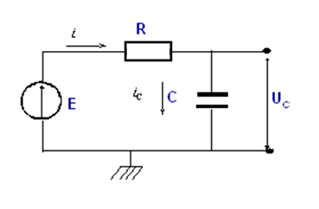

7. Draw the BOND GRAPH model of the mechanical system! (Use standard notation.)
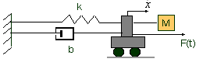

8. The drawing shown below is pictorial representations of real drive that are commonly encountered. (Simple motor drive)
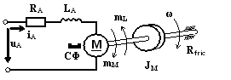
- Make a freehand sketch of the BOND GRAPH representation of motor drive (use the correct effort and flow description)!
- Write the dynamic equations of the elements and junctions of motor drive!

9. The drawing shown below is pictorial representations of real mechanism (without electric energy) that are commonly encountered. (hand-operated mechanical water pump)

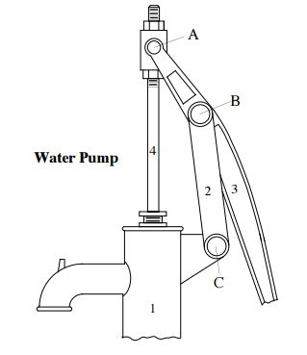 | Make a freehand sketch of the kinematic schematic representation (model) of mechanism.
- Calculate number of degrees of freedom!
- Make a freehand sketch of the BOND GRAPH representation of water pump (use the correct effort and flow description)!
- Write the dynamic equations of the elements and junctions of water pump!

