FACULTY-SPECIFIC GUIDANCE TO REFERENCING
(FOR MECHANICAL ENG. STUDENTS)
MIHÁLY CSÜLLÖG – MRS ÁGNES SZABÓ KOVÁCS (ENGINEERING LIBRARY)

Guide to Referencing

Referencing: The works consulted in the course of writing a scientific paper, a study, an article, a thesis, etc. are to be referenced properly.

- Citation

Plagiarism means representing someone else’s idea or language, as if they were our own. There are so-called text-matching pieces of software which are designed to filter out plagiarised material.

Types of citation:

- Word-for-word (verbatim) citation: using quotation marks, omission from or addition to the original sentence is not possible, word order cannot be changed
- Summarising or paraphrasing someone else’s idea or work: no question marks are to be used

No matter which type of citation is used, author and source should be referenced properly.

  - Preconditions for citation

- some parts of the work can be referenced but the entire work cannot be cited
- citation is possible to a certain extent (for e.g. to explain sg.)
- adherence to the original text
- citation can exclusively take a supplementary role, it cannot have an essential role
- any source of information should be referenced properly
- referencing can only take place in the author’s own work
- in the case of fine art, photography or industrial arts citation is not allowed because this would result in the truncation or distortion of the piece of work

  - Means of citation

- in the text

- directly after the cited part, in brackets: author’s last name, the first element of the entry (if there is no author, then the first word of the title) and year of publication. In case of word-for-word citation and/or paraphrasing exact page number should be indicated, for e.g. (Szűcs, 2007. p. 56.)
- directly after the cited part, referencing numbered in superscript, using footnote. The footnote must include where the source is from, the source must be described (see paragraph 2.2, for e.g. p. 12-13.). Each cited part should be numbered. If a document has been referenced five times, five different footnotes are to be made (if there are two or more footnotes from the same document, then it is enough to indicate the exact source only in the first case, in the rest of the cases the abbreviation, ib. or ibid. (Latin ibidem, in the same place) is to be used)
- directly after the cited part, numbering indicated in square brackets, using footnote
In this case even if the document has been referenced five times, one endnote will suffice, there is no need to make five. The first instance of citation (directly after the cited part), will be assigned to a number, for e.g. [5] and from this onwards each citation from the same document will be allocated to this number. In the endnote they appear according to these numbers – logically beginning from one ranked in ascending order, after that the document referenced properly, in alphabetical order but not necessarily (see paragraph 2.2)

Endnote is at the same time the List of references.

Example for endnote:

[1.] Barótfi I.: A napenergia hasznosítása. In: Barótfi I. (ed.): Környezettechnika. Mezőgazda., Budapest, 2000. p. 32–70. ISBN 963 286 009 8

[2.]Kovács J. – Takács G. –Takács M.: Analízis. Nemzeti Tankvk., Budapest,
2007. ISBN 963999111 78

[3.] Kovács P.: Finn nyomokon, avagy tradíció a finn építészetben. In:
Építészfórum {online} http://epiteszforum.hu/node/17575 (Accessed: 16.02.2011 11.47 a.m.)

- at the end of the text, in the List of references
The List of references is an obligatory part of thesis.
The List of references is to be prepared if citation within the text is used

- referencing: directly after the cited text, numbered in superscript, using the footnote
- referencing: directly after the cited part in brackets

If previously the endnote has been selected to list the works consulted, then there is no need to make a List of references/Bibliography because the endnote is at the same time the List of references.

The List of references should include all the works referred to in the main text.

Purpose of the List of references/Endnote is to show which materials and literature the author knows and has utilized. Each information should be referenced independent from the extent to which the information has been utilized. It is important to list only the documents which have been previously used in the course of writing a piece of work.

Example for List of references:

[4.] MSZ EN 12261:2002/A1 Gázmérők. Turbinás gázmérők. In force from: 1 November 2016. Magyar Szabványügyi Hivatal, Budapest, 2006.
[5.] Barótfi I.: A napenergia hasznosítása. In: Barótfi I. (ed.):
Környezettechnika. Mezőgazda., Budapest, 2000. p. 32–70. ISBN 963 286 009 8
[6.] Kovács J. – Takács G. – Takács M.: Analízis. Nemzeti Tankvk., Budapest, 2007. ISBN 963999111 78
[7.] Kovács P.: Finn nyomokon, avagy tradíció a finn építészetben. In: Építészfórum {online} http://epiteszforum.hu/node/17575 (Accessed:
16.02.2011 11.47 p.m.)
[8.] MUREXIN Korlátolt Felelősségű Társaság: Betonol csemperagasztási
rendszer. MUREXIN Kft., Budapest,1997.
[9.] Tiba Zs.: Dinamikai szimulációs program fejlesztése. In: Gép 2008. 59./8. p.28- 32. ISSN 9999-1111

2.Citing documents correctly

2.1.General rules for preparing List of references (Endnote)

The List of references or Endnote precisely prepared proves the author’s academic credibility and accuracy and that he/she has not committed plagiarism.

Rules:

- Entries should be numbered. Each entry may occur only once.
Important! In the case of endnote please see section 1.2
Endnote is at the same time the List of references.
- different forms are accepted when ordering the entries:

- Standards (if applicable) should occupy the first place. Afterwards the rest of the sources are listed in alphabetical order: author, title, publisher, place of publication, year of publication, page number is not necessary (except for articles where the indication of page number is necessary). Also, it is necessary to indicate ISBN and ISSN numbers.
- The resources should be ordered according to document types, within the document types the alphabetical order is to be followed.
- For endnote please see section 1.2.

- By writing out the author’s name title (Dr, Prof, PhD, etc.) and position (head, dean, etc.) are to be omitted.
In case of a non-Hungarian author, the last name should be placed in the first place, then the first name separated by comma.

E.g.: Frampton, Kenneth
- If there are more than 3 authors, only the first one is to be mentioned, afterwards the note [et al.] should occur.
E.g. Pum Pál [et al.]

- If the author’s name is not indicated, then the entry should start with the title.
- If the author’s name is not given, but there is an editor, then the entry should start with the editor’s name, for e.g. Kiss János (ed.)
- If the place of publication is unknown, then this notation is used: sine loco [s.l.] or [?]
- If the publisher is unknown, then this notation is used: sine nomine [s.n.] or [?]
- The List of references should include the page number of the cited document. (Attention! In case of book chapters, articles or proceedings only those page numbers are indicated where the aforementioned pieces of work can precisely be found.)
- When referring to an electronic source, the following data must be indicated: author, title, webpage. If it is not applicable, then it is enough to give the URL address and the date on which the resource or website was accessed.
- In the case of electronic lecture notes, electronic study guide/tutorial or any other electronic documents please see section 2.2. The difference is that after the title of the electronic document it should be indicated in brackets that this is an electronic document.
Example:
GUIDE for Preparing Thesis (electronic lecture note). Debrecen: Debreceni Egyetem Műszaki Kar Gépészmérnöki Tanszék, [?].

  - Standard referencing style for Mechanical Eng. students

In the following some examples for different types of referencing are listed:

- Books with one or more author:
- last name and first name of the authors: Kovács J. – Takács G. – Takács M.
- title of the work (in italics): Analízis
- name of publisher: Nemzeti Tankönyvkiadó
- place of publication: Budapest
- year of publication: 2007.
- ISBN number of the book
Example:

4 Kovács J. – Takács G. – Takács M.: Analízis, Nemzeti Tankönyvkiadó, Budapest, 2007. ISBN 963 999 111 78.

- Chapter from book/conference proceeding
- author(s): Hajdu S. – Gáspár P.
- title of the chapter from book/conference proceeding: Investigation of the influence of lifted load on dynamical behavior of stacker cranes through unstructured uncertainties
- after the note „In”, the whole bibliographical data in italics is to be provided (for e.g. title of the conference proceeding: CINTI 2013: Proceeding of the 14th IEEE International Symposium on Computational Intelligence and Informatics, place of publication: Budapest, name of publisher: IEEE Hungary Section)
- after the note “In”, bibliographical data of the book should be given in which the particular book chapter is included, for e.g.

author’s name: Barótfi I.
title of the book: Környezettechnika
name of publisher: Mezőgazda
place of publication: Budapest
year of publication: 2000
page number of the study: p. 32-70.
ISBN

Example:
5 Barótfi I.: A napenergia hasznosítása. In: Barótfi I. (ed.): Környezettechnika. Mezőgazda, Budapest, 2000. p. 32-70. ISBN 963 286 0098.

- Articles from journals
- name of the author: Tiba Zs.
- title of the article: Dinamikai szimulációs program fejlesztése
- after the note „In”, title of the journal (in italics): Gép
- year of publication: 2008
- volume number: 59
- month (or part) number: 8
- page numbers: p. 28–32.
- ISSN number

Example:
[6] Tiba Zs.: Dinamikai szimulációs program fejlesztése, In: Gép, 2008, 59(8), p. 28–32. ISSN 9999-1111.
d) Standards
- reference number of the standard: MSZ EN 13155:2004
- title of the standard: Daruk. Biztonság. Oldható teherfelvevők
- in force from: 1 April 2005
- date of withdrawal, if applicable
- publisher: Magyar Szabványügyi Testület
- place of publication: Budapest
- year of publication: 2005

Example:
[7] MSZ EN 13155:2004 Daruk. Biztonság. Oldható teherfelvevők, In force from: 1 April 2005, Magyar Szabványügyi Testület, Budapest, 2005.
e) Product descriptions
- manufacturer (author): Freudenberg-Megulastik
- title: Standard Components for Vibration Isolation
- publisher: Carl Freudenberg
- place of publication: Weinheim
- year of publication: 2001

Example:
[8] Freudenberg-Megulastik: Standard Components for Vibration Isolation, Carl Freudenberg, Weinheim, 2001.
f) Online sources
- author: Lévai Z.
- title: Dízelmotorok keverékképzése
- after „In”, title of the website: Gépjárművek szerkezettana
- followed by {online}
- Website address (URL): http://www.lezo.hu/szerkezettan/hajtas/motor/dizel/dizel.html
- date on which the resource or website was accessed: day, month, year, hour, minute (in round brackets): Accessed 31.03.2017, 8.20 a.m.

Example:
[9] Lévai Z.: Dízelmotorok keverékképzése, In: Gépjárművek szerkezettana {online} http://www.lezo.hu/szerkezettan/hajtas/motor/dizel/dizel.html (Accessed 31.03.2017, 8.20 a.m.)

- Pictures, tables, figures

Almost each thesis contains tables and figures. The guide below is designed to assist students with using and referencing them.

Referencing within the text

Important! The particular picture/figure is to be mentioned in the text. Its role and purpose should be explained. The reader may not be expected to decode its essence.

(For e.g. Geographical factors influencing the migration of cranes – illustrated in figure 2 – this is of vital importance because ...)

The particular picture/figure has a title which should be indicated underneath or above the picture/figure.
For e.g.

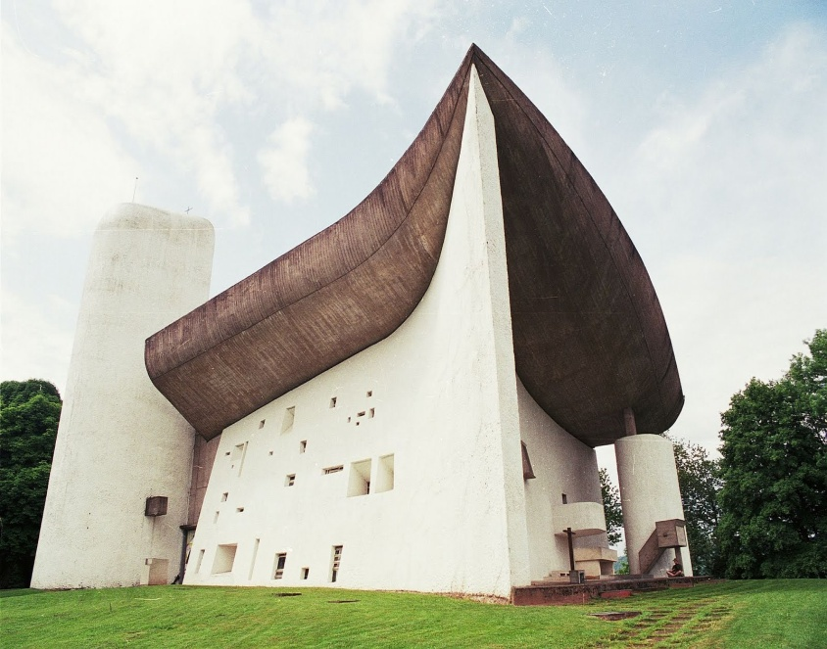

Figure 1: Le Corbusier's Notre-Dame-du-Haut
(Source:http://eliinbar.files.wordpress.com/2012/12/ronchamp-1.jpg)

Each figure/picture has a source which is to be indicated (reference)!

Important: it should be unambiguous what the basis was.

If the figure/picture is self-made, then the source should be indicated in the following way:
For e.g. Figure 2: Geographical factors influencing the migration of cranes (Source: self-made or source: self-edited)

If it is an online source:
Figure 2: Geographical factors influencing the migration of cranes (Source: www.darvakvandorlasa.hu)
The List of references or Endnote should precisely include (according to the referencing style pertaining to online sources) where the source is from.

If the source is a printed document, then it is sufficient to give the document’s author, year of publication and page number underneath the picture/figure.
For e.g. Figure 2: Geographical factors influencing the migration of cranes (Source: Kiss. 2000, 15.)

If there is an endnote, then
For e.g. Figure 2: Geographical factors influencing the migration of cranes (Source: [8])

Referencing at the end of the piece of work:

The List of references or Endnote should include all the sources which refer to pictures, tables and figures by following the above outlined guide to referencing.

Formal requirements:

The List of references/Bibliography or the Appendix is followed by the Table of pictures/figures/diagrams in the piece of work.

Important! Please indicate the page number on which the particular picture, table, figure is to be found.

Example for Table of figures/pictures:

Figure 1: Le Corbusier’s Notre-Dame-du-Haut…………5.
Figure 2…….. …..8.
Figure 3………….. ….10.

Example for List of references/Bibliography

- Hepp Nóra, Fejesné Lőrincz Anna: Szerzői jog. Budapest: Szellemi Tulajdon Nemzeti Hivatala, 2012. ISBN 9789639157705
- https://eliinbar.files.wordpress.com/2012/12/ronchamp-1.jpg Accessed: 10.02.2013, 10:12 a.m.

